Model Steering Control Unit

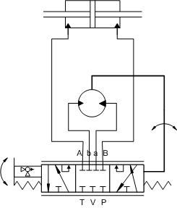
The Steering control unit hydraulics schematic as shown in the figure consists of directional valve that controlled by steering angle as an input, hydraulics cylinder that mechanically linked to the steering linkage, and hydraulics motor for feedback.
As a result, the systems will generate proportionality between steering angle and cylinder displacement, and acts as a torque amplifier.

- Create a new Simulink Model
In the Simulink Library browser, select File->New->Model.

- First, independently create the valve shown in the figure using variable orifice:
0
-
+
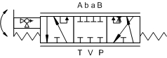
The controlled valve is a 7-port 3-position with position to the left corresponds to positive command signal. Inversely, position to the right corresponds to negative command signal. Neutral position is in the middle when command signal is zero.

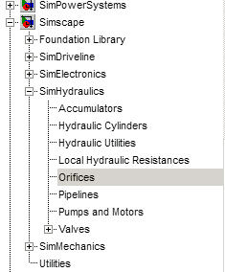
- From the “Simscape/SimHydraulics/Orifices” drag a “Variable Orifice” block into your model.

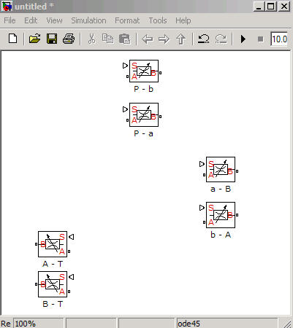
- Copy the Variable Orifice to make 6 blocks. Rename each block as shown in the figure.
Inverse the direction of valve A-T and B-T.

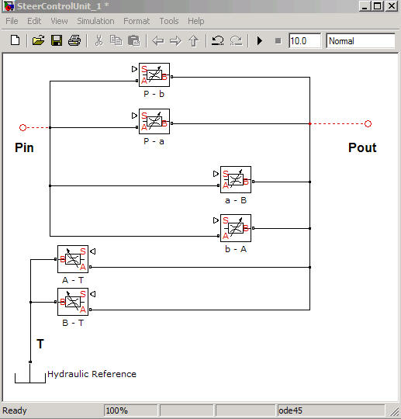
- Construct flow test model by connecting the blocks as shown in the figure below. From “Simscape/Foundation Library/Hydraulics/Hydraulics Elements” drag “Hydraulics Reference” block and connect to the “B” port of orifice A-T and B-T.

- Add “Signal Builder” from “Simulink/Sources” library. From “Simscape/Utilities” library drag “Simulink-PS Converter” block, connect the output of the converter block to signal input port of each orifice. Double click on the converter block and type or pick from drop down menu “mm” in the Input signal unit.
- Add pressure source for Pin and Pout by dragging “Ideal Hydraulics pressure Source” from “Simscape/Foundation Library/Hydraulics/Hydraulics Sensors and Sources”. Also drag “Hydraulics Reference” block from “Simscape/Foundation Library/Hydraulics/Hydraulics Elements” Library, connect to T port of the Pressure Source block. Add “Constant” block from ”Simulink/Sources” Library and “Simulink-PS Converter” block for pressure source input value. Set Pin value higher than Pout value so that flow from Pin to Pout is positive. (i.e. Pin=1450psi and Pout=500psi). Double click on the converter, type psi for Input signal unit.

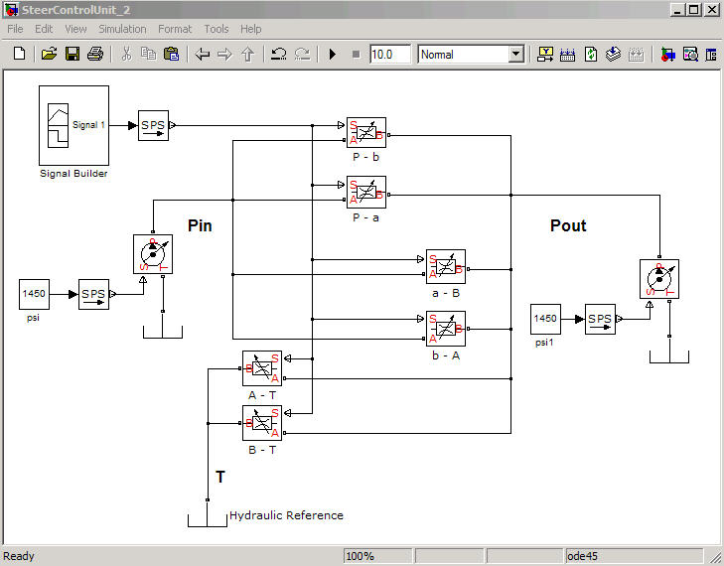
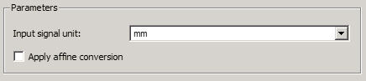

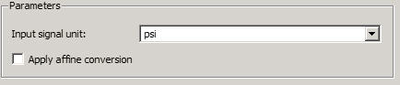
- Double click on the “Signal Builder” and set the signal value as follow:
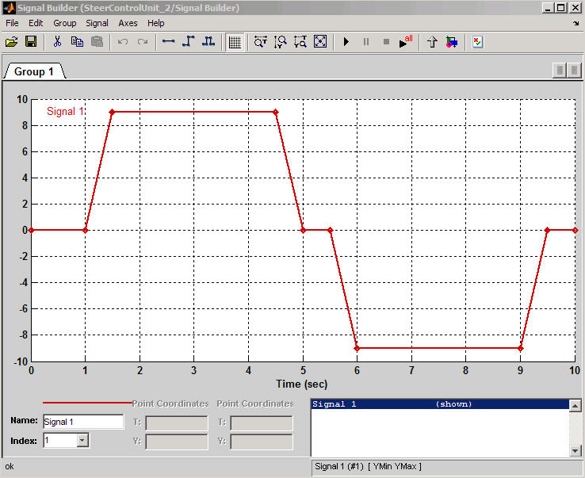

Signal direction and corresponding valve direction.
From the valve symbol:
0
-
+
- At neutral position (command signal is 0), all connections are close.
- At positive position (command signal is positive), the connection become P->b, a->B, and A->T.
- At negative position (command signal is negative), the connection become P->a, b->A, and B->T.

  - Double click on the variable orifice and set the parameters as follows:

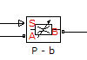
Orifice | Orifice Max Area [m^2] | Orifice Max Opening [mm] | Orifice Orientation | Initial Opening  [mm]
P – b | 5e-5 | 6 | Opens in Positive Direction | -3
P – a | 5e-5 | 6 | Opens in Negative Direction | -3
a - B | 5e-5 | 6 | Opens in Positive Direction | -3
b - A | 5e-5 | 6 | Opens in Negative Direction | -3
A - T | 5e-5 | 6 | Opens in Positive Direction | 0
B - T | 5e-5 | 6 | Opens in Negative Direction | 0

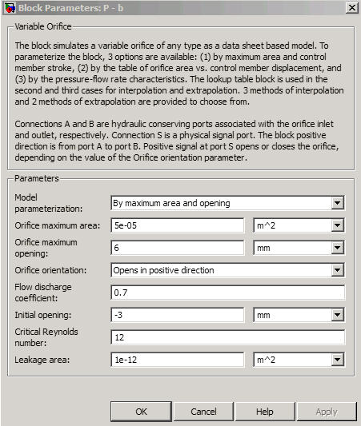

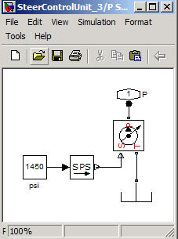
  - Create subsystem for pressure source
Highlight pressure source blocks (Constant Source, S->PS Converter, Ideal Pressure Source), Edit->Create Subsystem.
In the subsystem block, rename Physical Modeling Connection block to “P”.
Rename the subsystem block to “P Source 1450psi”.

Similarly, create subsystem for other pressure source for Pout.

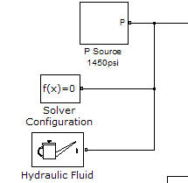
  - From ”Simscape/Utilities” drag “Solver Configuration” block and connect it to any part of the hydraulics circuit.
  - Similarly from the “Simscape/SimHydraulics/Hydraulics Utilities” drag “Hydraulics Fluid” and connect it to the hydraulics network as shown in the figure. Double click on the Hydraulic Fluid block, from the drop down menu choose “Fluid MIL-F-83282” in Hydraulic fluid menu.

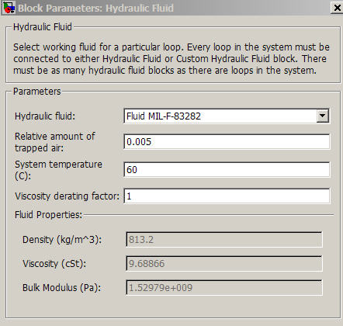

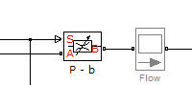
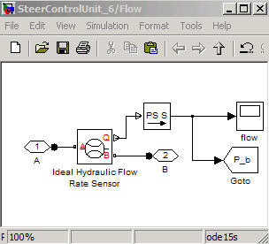
  - To monitor the flow at each orifice, add flow scope from Simscape Scopes Library or drag “Ideal Hydraulic Flow Sensor” from “Simscape/Foundation Library/Hydraulics/Hydraulics Sensors and Sources”.

  - Set the solver to ode 15s: Simulation->Configuration Parameters-> Solver.
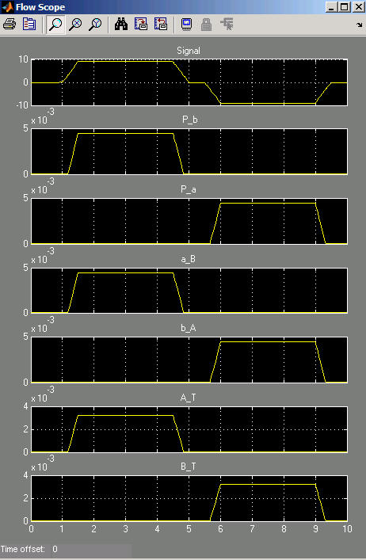
  - Run the model for 10s and check the flow on each orifice, the result should be similar to the following plot.

P-b, a-B, and A-T valves are open when command signal is positive. Otherwise, flow is zero.
Vice versa, P-a, b-A, and B-T valves are open when command signal is negative. Otherwise, flow is zero.

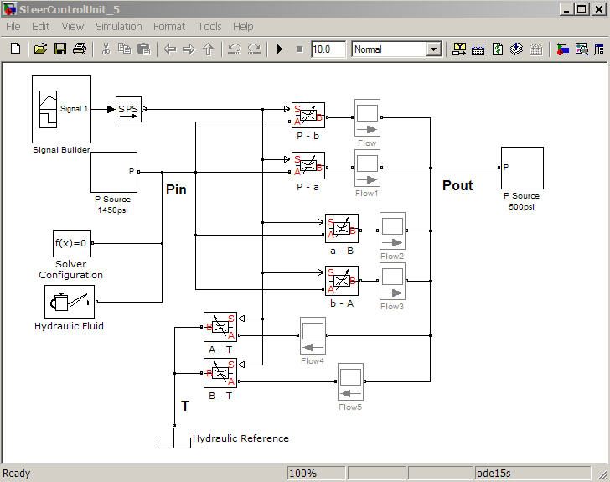

- Reconfigure the orifice for open loop system.
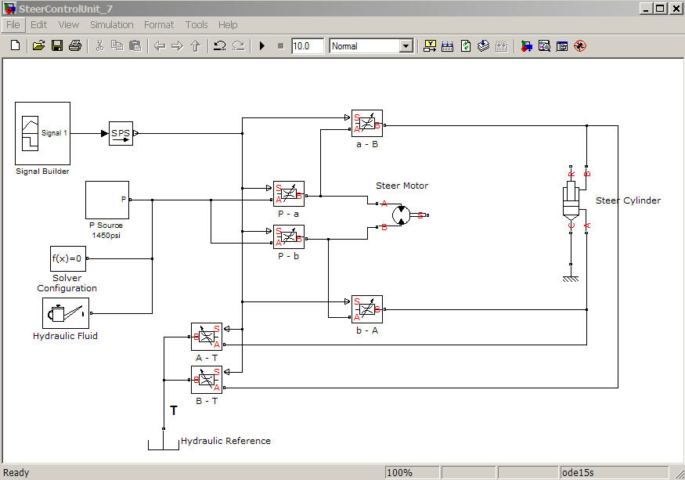
- Reconfigure the orifices as shown in the figure.

- Drag to the model “Double-Acting Hydraulic Cylinder” from “Simscape/SimHydraulics/Hydraulic Cylinders” library.
- Drag to the model “Hydraulic Motor” from “Simscape/SimHydraulics/Pumps and Motors” library.
- Configure Motor and Cylinder as shown in the figure above.
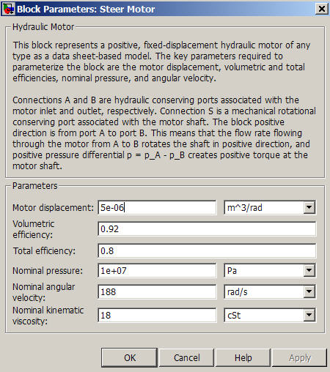
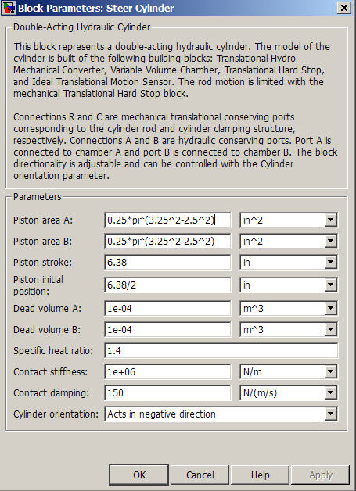
- Set parameters in the Motor and Cylinder as follows:

- Rename the motor to “Steer Motor”, and the cylinder to “steer Cylinder”.

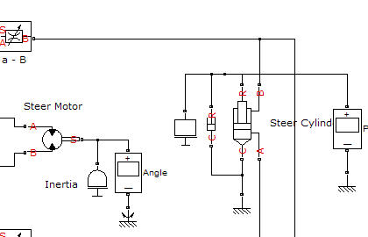
- Add “Inertia” to Steer Motor mechanical output, and mass and damper to the cylinder. Configure as shown below.

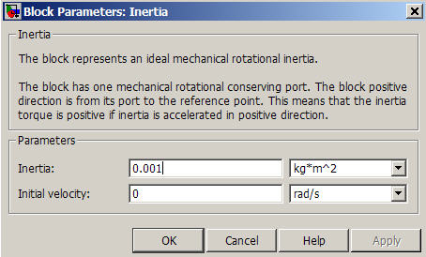
- Set “Inertia”, “mass”, and “Damper” parameters:

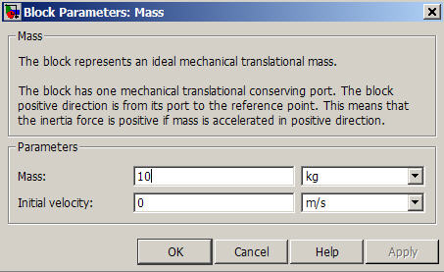

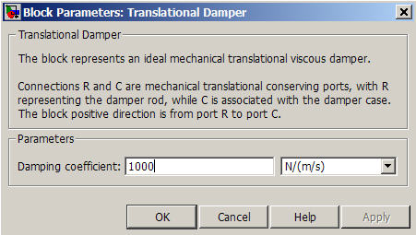

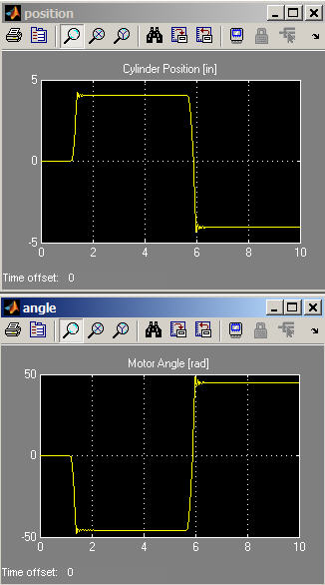
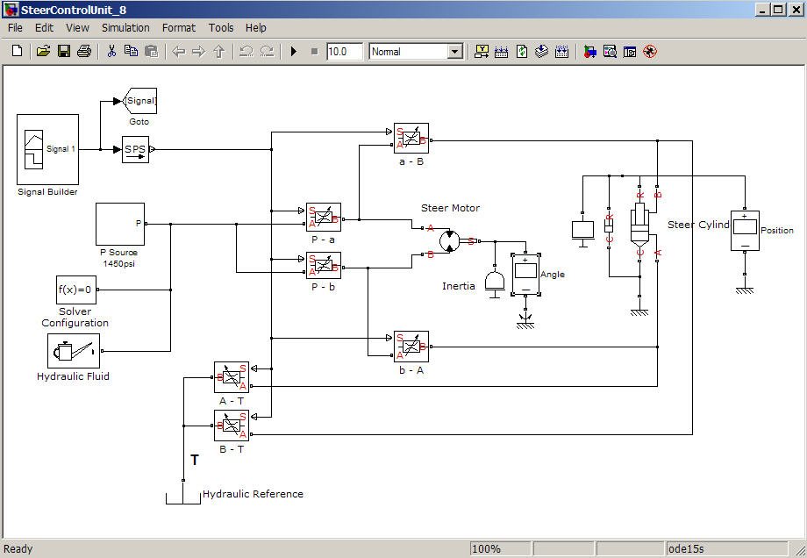
- The plot result for Cylinder position and Motor Angle should be similar to the plots on the right.

  - Closed loop systems.
Model simple closed loop mechanism by feeding back angle from motor output into the command signal through subtraction.
- Add “Ideal Rotational Motion Sensor”, “Mechanical Rotational Reference”, “PS Subtract”, and “Gain” block from “Simscape/Foundation Library”.
- Configure the blocks to the model as shown in the figure below.
- Set “Gain” parameter to -1.
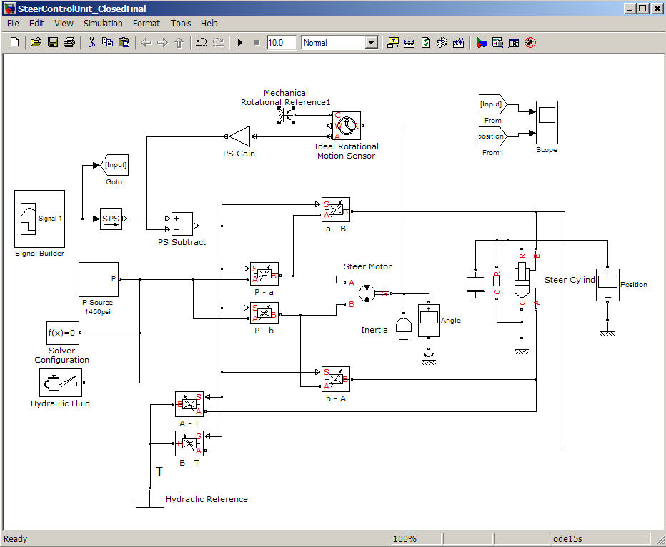

- Run the model for 10s, and plot the Steer Cylinder Position with comparison of Command Signal. The result should be similar to the plot below.
